HC-SR04 Ultrasonic sensor instruction

1. Product Features:

The HC-SR04 Ultrasonic Ranging Module provides 2cm-400cm non-contact distance sensing with a range accuracy of up to 3mm. The module includes an ultrasonic transmitter, receiver and control circuitry.

Basic working principle:

(1) Use IO port TRIG to trigger ranging, and give a minimum level of 10us.

(2) The module automatically sends 8 square waves with 40khz to automatically detect whether there is a signal return;

(3) There is a signal return, and a high level is being output through the IO port ECHO, and the high level duration is the time from the transmission to the return of the ultrasonic wave. Test distance = (high time * sound speed (340M / S)) / 2;

2 physical map:

Wiring as shown on the below, VCC for 5V

Power, GND is ground,

TRIG triggers control signal input, ECHO echo signal output and other four interface terminals.

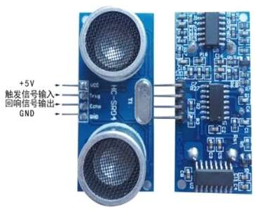

3 Electrical parameter

|  |  |
| --- | --- |
| Electrical parameter | HC-SR04 Ultrasonic module |
| Working Voltage | DC 5 V |
| Working current | 15mA |
| Working frequency | 40kHz |
| Farthest range | 4m |
| Nearest range | 2cm |
| Measuring angle | 15 degree |
| Input trigger signal | 10uS TTL pulse |
| Output echo signal | Output TTL level signal, proportional to range |
| Standard size | 45*20*15mm |

4 Ultrasonic sequence chart

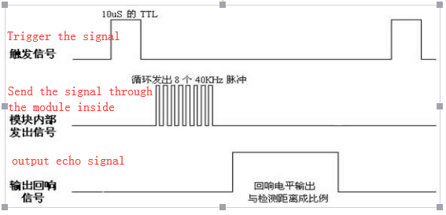

The above sequence chart shows that you only need to provide a pulse trigger signal of more than 10uS. The module will internally emit eight 40kHz cycle levels and detect echoes. The echo signal is output as soon as an echo signal being detected. The pulse width of the echo signal is proportional to the measured distance. The distance can thus be calculated by transmitting a signal to the received echo signal time interval. Formula: uS/58=cm or uS/148=inches; or:

distance= High time* Sound speed (340M/S)/2;

The recommended measurement period is 60ms or more to prevent the effect of the transmitted signal on the echo signal.

Note: (1). This module should not be connected with power. If you want to connect with power, first connect the GND terminal of the module first, otherwise it will affect the normal operation of the module.

(2). When measuring distance, the area of the measured object is not less than 0.5 square meters and the plane should be flat as much as possible, otherwise it will affect the measurement result.

5 Physical specifications

